2.1 Functions and Prototyping

This section will guide you to:

* Create a JavaScript project in your IDE
* Write a program in JavaScript to create functions and prototypes

This lab has three subsections, namely:

2.1.1 Writing a program in JavaScript to verify implementations of functions and prototypes

2.1.2 Executing the program and verifying working of functions and prototypes

2.1.3 Pushing the code to your GitHub repositories

**Step 2.1.1:** Writing a program in JavaScript to verify implementations of functions and prototypes

* Open Visual Studio Code
* *[Right click]* on the **src** folder of the project
* Select *New File* -> Enter the filename as **index.html**
* Write the code shown below resolving the warning and errors due compatibility-related issues

<html>

<body>

<h1>MEAN Stack</h1>

<p> Lesson 2 Demos </p>

<script src="functions_and_prototypes.js"></script>

</body>

</html>

* *[Right click]* on the **src** folder of the project
* Select *New File* -> Enter the filename as **functions_and_prototypes.js**
* Execute the code shown below resolving the warning and errors due compatibility-related issues

// function constructor

function Employee(name, designation, yearOfBirth){

this.name= name;

this.designation= designation;

this.yearOfBirth= yearOfBirth;

}

// creating calculateAge() method to the Prototype property

Employee.prototype.calculateAge= function(){

console.log('The current age is: '+(2019- this.yearOfBirth));

}

console.log(Employee.prototype);

// creating Objects

let Emp1= new Employee('Alex', 'Junior Tester', 1995);

console.log(Emp1) ;

Emp1.calculateAge();

let Emp2= new Employee('Dexter', 'Senior Software Developer', 1990);

console.log(Emp2)

Emp2.calculateAge();

let Emp3= new Employee('Annie', 'Junior HR', 1998);

console.log(Emp3)

Emp3.calculateAge();

**Step 2.1.2:** Executing the program and verifying working of functions and prototypes

Before you execute the program, check for syntactical corrections. If no errors are found, follow the steps mentioned below:

* Go to Extensions and download **Live Server**
* *[Right click]* on the **index.html** file of the project
* Select *Open with Live Server*
* Right click when the server starts running. Select *Inspect* *Element.* Click on ***Console****.*

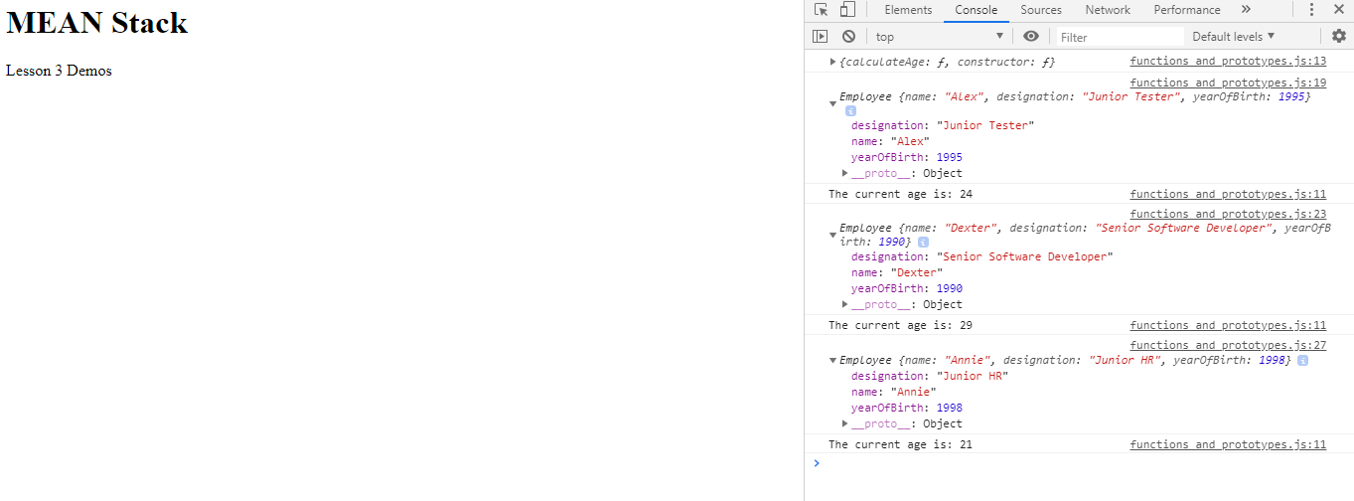

**Step 2.1.3:** Pushing the code to your GitHub repositories

Open your command prompt and navigate to the folder where you have created your files.

cd <folder path>

Initialize your repository using the following command:

git init

Add all the files to your git repository using the following command:

git add . 

Commit the changes using the following command:

git commit . -m “Changes have been committed.”

Push the files to the folder you initially created using the following command:

git push -u origin master